**UCS 2312 Data Structures Lab**

**Exercise 2: ListADT and its applications**

**Date of Exercise: 19.09.2023**

Create an ADT for the linked list data structure with the following functions. list*ADT* will have the integer array and size. [CO1, K3]

1. insert(header,data) – Insert data into the list using inserting at front
2. display(header) – Display the elements of the list
3. insertAtEnd(header,data) – Insert data at the end of the list
4. searchElt(header, key) – return the value if found, otherwise return -1
5. findMiddleElt(header) – find the middle element in the list
6. reverseList(header) – Reverse the list
7. detectLoop(header) – return the status of whether the loop is present or not
8. deleteElt(header,data) – Deletes the element data

Write a program in C to test the listADT for its operations with the following test cases.

|  |  |
| --- | --- |
| **Operation** | **Expected Output** |
| length(header) | 0 |
| insert(header,2) | 2 |
| insert(header,4) | 4, 2 |
| insert(header,6) | 6, 4, 2 |
| insert(header,8) | 8, 6, 4, 2 |
| length(header) | 4 |
| insertLast(header,1) | 8, 6, 4, 2, 1 |
| insertLast(header,3) | 8, 6, 4, 2, 1, 3 |
| length(header) | 6 |
| findMiddleElt(header) | 2 or 4 |
| reverseList(header) | 3, 1, 2, 4, 6, 8 |
| searchElt(4) | 4 |
| searchElt(5) | -1 |
| deleteElt(2) | 8, 6, 4, 1, 3 |

Best practices to be followed:

* Design before coding
* Usage of algorithm notation
* Use of multi-file C program
* Versioning of code

**Data Structure – Linked List:**

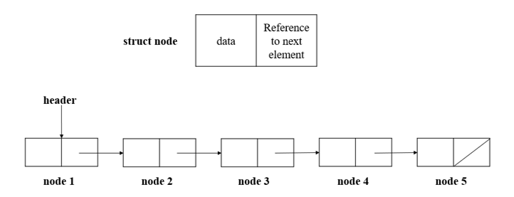

**Algorithm –**

**Algorithm: Find the middle element in the list**

Input – Pointer to header node

Output – void

1. count=0 and mid=header
2. while (header != NULL)

if count & 1

mid=mid->next

++count

header=header->next

1. if mid != NULL

print mid->data

**Algorithm: Reverse the list**

Input – Pointer to header node

Output – void

1. prev=NULL
2. curr=header->next
3. while (curr != NULL)

next = curr->next

curr->next = prev

prev = curr

curr = next

1. header->next = prev

**Algorithm: Return the status of whether the loop is present or not**

Input – Pointer to header node

Output – int

1. ptr1 = header->next
2. ptr2 = header
3. while (ptr1 != NULL)

while (ptr2->next != ptr1)

if ptr2 == ptr1->next

return 1

ptr2 = ptr2->next

ptr2 = header

ptr1 = ptr1->next

1. return 0

**main.c code:**

#include <stdio.h>

#include <stdlib.h>

#include "LinkedADT.h"

void main()

{

struct node *head = (struct node*) malloc(sizeof(struct node));

head->next = NULL;

printf("ENTER FIRST ELEMENT: ");

int value;

scanf("%d", &value);

create(head, value);

int choice;

while(choice + 1)

{

printf("\n-1: EXIT\n 0: DISPLAY\n 1: APPEND(INSERT AT END)\n 2: INSERT AT BEGINNING\n 3: INSERT AFTER DATA\n 4: DELETE AT FRONT");

printf("\n 5: DELETE AT END\n 6: DELETE DATA\n 7: SEARCH DATA\n 8: REVERSE\n 9: MIDDLE ELEMENT\n 10: DETECT LOOP\nChoice : ");

scanf("%d", &choice);

switch (choice)

{

case -1: break;

case 0:

{

display(head);

break;

}

case 1:

{

printf("\nENTER NEW ELEMENT: ");

int data;

scanf("%d", &data);

append(head, data);

printf("New List : ");

display(head);

break;

}

case 2:

{

printf("\nENTER NEW ELEMENT: ");

int data;

scanf("%d", &data);

insertAtFront(head, data);

printf("New List : ");

display(head);

break;

}

case 3:

{

printf("\nENTER NEW ELEMENT: ");

int data;

scanf("%d", &data);

printf("\nENTER KEY: ");

int key;

scanf("%d", &key);

insertAfter(head, data, key);

printf("New List : ");

display(head);

break;

}

case 4:

{

deleteAtFront(head);

printf("New List : ");

display(head);

break;

}

case 5:

{

deleteAtEnd(head);

printf("New List : ");

display(head);

break;

}

case 6:

{

printf("\nENTER ELEMENT TO DELETE: ");

int data;

scanf("%d", &data);

deleteData(head, data);

printf("New List : ");

display(head);

break;

}

case 7:

{

printf("\nENTER DATA TO SEARCH: ");

int data;

scanf("%d", &data);

if(search(head, data)!=NULL)

{

printf("ELEMENT FOUND\n");

}

else

{

printf("ELEMENT NOT FOUND\n");

}

break;

}

case 8:

{

printf("\nLIST REVERSED ");

reverse(head);

printf("New List : ");

display(head);

break;

}

case 9:

{

printMiddle(head);

}

case 10:

{

if(detectLoop(head))

{

printf("\nLoop Present\n");

}

else

{

printf("\nNo Loop Present\n");

}

break;

}

case 11:

{

head->next->next->next->next=head->next;

break;

}

default:

{

printf("\nINVALID CHOICE");

}

}

}

}

**LinkedADT.h code:**

struct node

{

int data;

struct node * next;

};

void create(struct node* header,int data)

{

struct node* temp;

temp=(struct node *)malloc(sizeof(struct node));

temp->data=data;

temp->next=header->next;

header->next=temp;

}

void append(struct node* header,int data)

{

struct node* temp;

temp=(struct node *)malloc(sizeof(struct node));

temp->data=data;

struct node* ptr;

ptr=header->next;

while((ptr->next)!=NULL)

{

ptr=ptr->next;

}

temp->next=ptr->next;

ptr->next=temp;

}

struct node* search(struct node* header,int key)

{

struct node* ptr;

ptr=header->next;

while(ptr!=NULL)

{

if(ptr->data==key)

{

return ptr;

}

ptr=ptr->next;

}

return NULL;

}

void insertAtFront(struct node* header,int data)

{

struct node* temp;

temp=(struct node *)malloc(sizeof(struct node));

temp->data=data;

temp->next=header->next;

header->next=temp;

}

void insertAfter(struct node* header,int data,int key)

{

struct node* temp;

temp=(struct node *)malloc(sizeof(struct node));

temp->data=data;

struct node* ptr;

ptr=search(header,key);

temp->next=ptr->next;

ptr->next=temp;

}

void deleteData(struct node* header,int data)

{

struct node* ptr;

ptr=header->next;

while(ptr!=NULL)

{

if((ptr->next->data)==data)

{

ptr->next=ptr->next->next;

}

ptr=ptr->next;

}

}

void deleteAtFront(struct node *header)

{

struct node *temp = header->next;

header->next = temp->next;

free(temp);

}

void deleteAtEnd(struct node* header)

{

struct node *temp = header->next;

while(temp->next->next != NULL)

{

temp = temp->next;

}

struct node *last = temp->next;

temp->next = last->next;

}

void display(struct node* header)

{

struct node* ptr;

ptr=header->next;

printf("Linked List => ");

while(ptr!=NULL)

{

printf("%d ",ptr->data);

ptr=ptr->next;

}

printf("\n");

}

void reverse(struct node * header)

{

struct node* prev=NULL;

struct node* curr=header->next;

struct node* next=NULL;

while (curr != NULL)

{

next = curr->next;

curr->next = prev;

prev = curr;

curr = next;

}

header->next = prev;

}

void printMiddle(struct node* header)

{

int count=0;

struct node* mid=header;

while(header!=NULL)

{

if(count & 1)

mid=mid->next;

++count;

header=header->next;

}

if (mid!=NULL)

printf("The middle element is %d\n",mid->data);

}

int detectLoop(struct node* header)

{

struct node *ptr1=header->next;

struct node *ptr2=header;

while(ptr1!=NULL)

{

while(ptr2->next!=ptr1)

{

if(ptr2==ptr1->next)

{

return 1;

}

ptr2=ptr2->next;

}

ptr2=header;

ptr1=ptr1->next;

}

return 0;

}

**Output:**

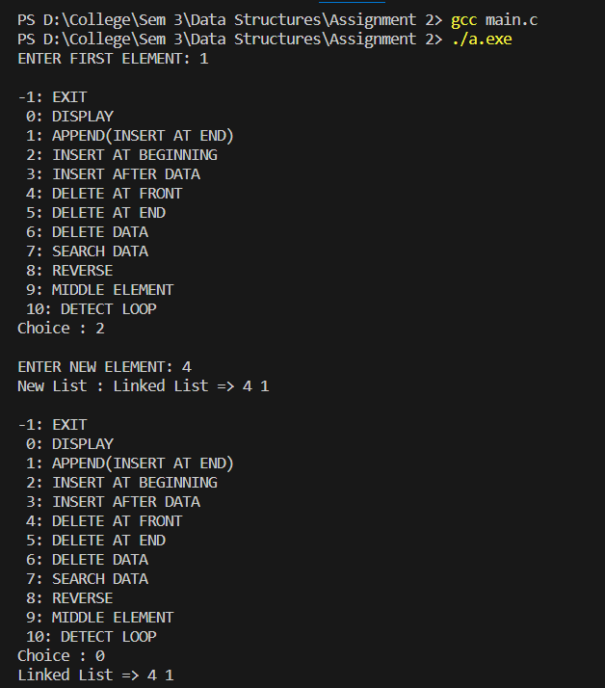

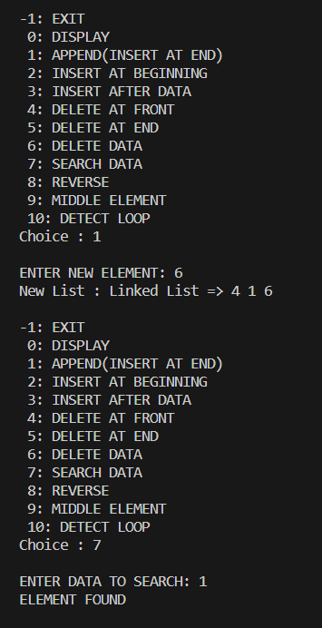

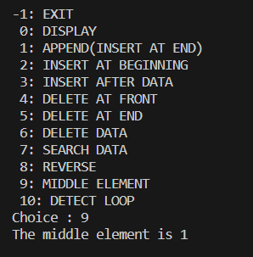

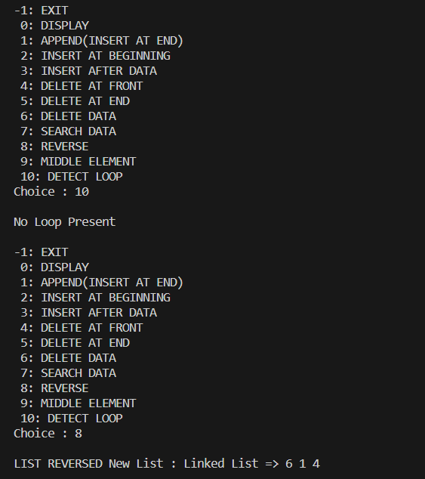

**POLYNOMIAL ADDITION:**

**Algorithm: Add two polynomials**

1. t=sum
2. while (p1->next != NULL)

insert (sum, p1->next->coef, p1->next->exp)

p1 = p1->next

1. while (p2->next != NULL)

flag=0

sum=t

while (sum->next != NULL)

if (p2->next->exp == sum->next->exp)

flag=1

sum->next->coef = sum->next->coef + p2->next->coef

sum = sum->next

if flag==0

insert (sum, p2->next->coef, p2->next->exp)

p2 = p2->next

**Polynomial.h code:**

struct node

{

int coef;

int exp;

struct node *next;

};

void insert(struct node *header, int coef, int exp)

{

struct node *temp=(struct node *)malloc(sizeof(struct node));

temp->coef=coef;

temp->exp=exp;

temp->next=NULL;

if(header->next==NULL)

{

header->next=temp;

}

else

{

struct node *current=header->next;

while (current->next!=NULL)

{

current=current->next;

}

current->next=temp;

}

}

void display(struct node *p)

{

struct node *current=p->next;

while(current!=NULL)

{

printf("%dx^%d",current->coef,current->exp);

current=current->next;

if (current!=NULL)

{

printf(" + ");

}

}

printf("\n");

}

void add(struct node* p1, struct node* p2, struct node* sum)

{

int flag;

struct node* t=sum;

while (p1->next!=NULL)

{

insert(sum,p1->next->coef,p1->next->exp);

p1=p1->next;

}

while (p2->next!=NULL)

{

flag=0;

sum=t;

while (sum->next!=NULL)

{

if(p2->next->exp==sum->next->exp)

{

flag=1;

sum->next->coef=sum->next->coef+p2->next->coef;

}

sum=sum->next;

}

if(flag==0)

{

insert(sum,p2->next->coef,p2->next->exp);

}

p2=p2->next;

}

}

**PolynomialMain.c code:**

#include <stdio.h>

#include <stdlib.h>

#include "Polynomial.h"

void main()

{

struct node *p1=(struct node *)malloc(sizeof(struct node));

struct node *p2=(struct node *)malloc(sizeof(struct node));

struct node *sum=(struct node *)malloc(sizeof(struct node));

p1->next=NULL;

p2->next=NULL;

sum->next=NULL;

int choice;

while(choice + 1)

{

printf("\n-1: EXIT\n 0: DISPLAY POLYNOMIALS\n 1: INSERT AT POLYNOMIAL 1\n 2: INSERT AT POLYNOMIAL 2\n 3: DISPLAY SUM\nChoice : ");

scanf("%d", &choice);

switch (choice)

{

case -1: break;

case 0:

{

printf("Polynomial 1: ");

display(p1);

printf("Polynomial 2: ");

display(p2);

break;

}

case 1:

{

printf("\nENTER COEFFICIENT AND EXPONENT: \n");

int coef,exp;

scanf("%d",&coef);

scanf("%d",&exp);

insert(p1,coef,exp);

break;

}

case 2:

{

printf("\nENTER COEFFICIENT AND EXPONENT: \n");

int coef,exp;

scanf("%d",&coef);

scanf("%d",&exp);

insert(p2,coef,exp);

break;

}

case 3:

{

printf("\nPOLYNOMIALS ADDED\n");

add(p1,p2,sum);

printf("Sum: ");

display(sum);

break;

}

default:

{

printf("\nINVALID CHOICE");

}

}

}

}

**Output:**

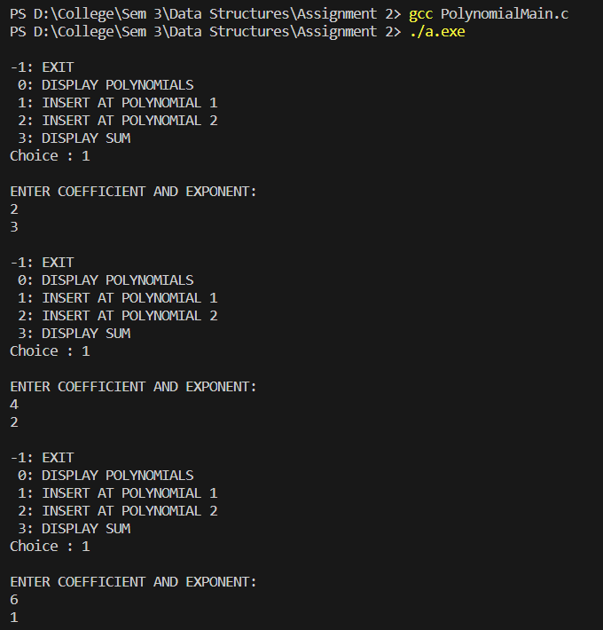

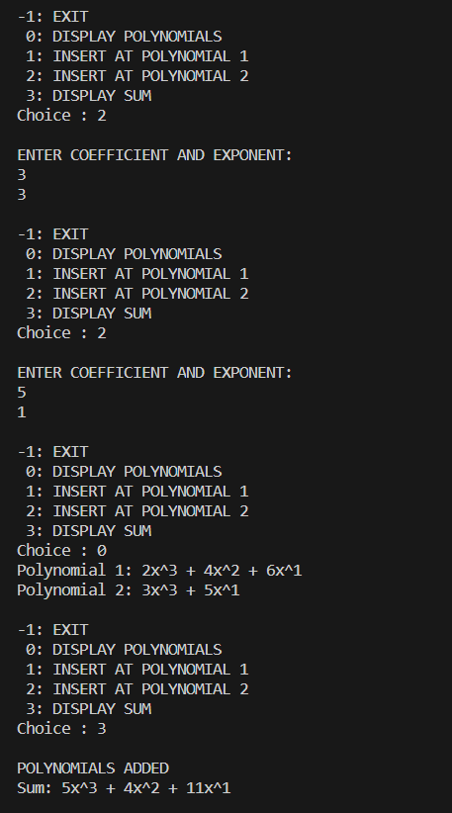

**Learning Outcome:**

